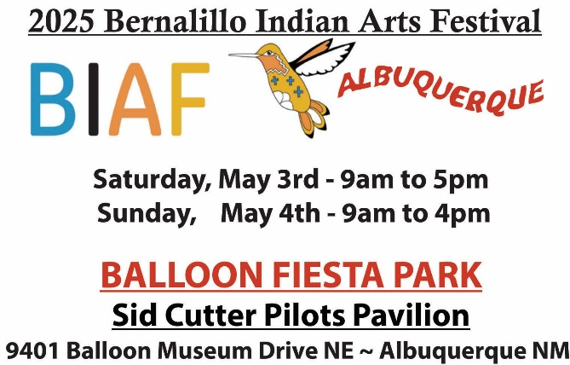

**RETURNING ARTIST APPLICATION (if you were in our market in 2024 – you are juried in!)**

**APPLICATION FEE: $35 due with application(non-refundable)**

NOTE: **Each booth-sharing artist MUST fill out application and MUST pay $35 application fee.**

*We accept money orders, PayPal, Visa, M.Card, Discover, Amex and cash.*

**CIB: We have your CIB on file…if not, we will notify you.**

**First Name ____________________________ Last Name_____________________________________**

**Address_____________________________________________________________________________**

**City ________________________________________ State ________ Zip/Postal Code _____________**

**Country __________________ Email _____________________________________________________**

**Phone (cell) ________________________________ (home) ___________________________________**

**Website URL:_________________________________________________________________________**

**Authentic Native Arts Association, Inc and the Bernalillo Indian Arts Festival comply with the Native American eligibility requirements of the Indian Arts & Crafts Act of 1990.**

**Juried Classification:**

**Select one or two of the following classifications of your artwork. Mark your primary classification with a “1,” secondary classification with a “2.”**

**You may sell only artwork in these classifications at the Festival and only items in your approved classification(s) will be allowed into Juried Competition.**

_**_________Jewelry and lapidary work _________Weavings and textiles**

**__________Pottery __________Basketry**

**__________Painting/drawing/graphics/photography __________Personal Attire**

**__________Wooden Carvings __________Beadwork & Quillwork**

**__________Sculpture (above 6”) __________Small Sculpture *(fetishes and non-Pueblo wooden carvings 6” and under).**

**__________Diverse arts ** Please give details of the type of Diverse Art (dolls, flutes, drums, bows and arrows, cultural items, etc.)**

______________________________________________________________________________________________________________________________________________________________________________________

***NOTE: 3 PHOTOS OF CURRENT ARTWORK MUST ACCOMPANY THIS APPLICATION.***

**Will you have alternative/Non-traditional Arts and Crafts Merchandise: yes_______no_________**

**Upon approval by ANAA committee, 10% of your market booth space can be for your commercial arts and crafts. Description and photos of commercial merchandise must be submitted to us. You must also disclose to the public the origin of this art.**

**For your information Re Booths: We only provide chairs & tables; displays, etc. are up to you. We will do our best to accommodate your preference but reserve the right to make the final assignment of booth location.**

**Pg.2**

INDOOR BOOTH SPACES (note: each artist must pay for his space individually.) CHECK ONE:

**Wall spaces – check here and also check a box above. 8x10 12x8**

**SHARINGI intend to share a booth with - Name: ____________________________________**

We provide tables and chairs. You are responsible for your own set-up and displays. We will do our best to accommodate your preference but reserve the right to make the final assignment of booth location.

**NOTE: Youth artists, age 17 and younger, may sell and share a booth with a Juried Booth mentor. Youth artists do not pay an application fee or booth fee; however, before Festival day, we must have the name of the Youth Artists, their CIB and three images of their work**.

Albuquerque New Mexico 2025 Gross receipts tax is 7.6250.

Authentic Native Arts Association, Inc is not responsible for collection the sales tax on items sold. Collection of sales tax is the responsibility of each artist. Since a list of our artist participants is available to the City of Albuquerque, and, since the city is gracious enough to support our market, we ask that you report

Gross Receipts tax to: BERNALILLO COUNTY, CITY of ALBUQUERQUE , Location Code 02-100 on your New Mexico Sales tax return.

**2025 Refund Policy: If the festival is cancelled because of wind or weather, there will be NO refunds, NO rollovers issued.**

1. $35 Application Fee is non-refundable

2. There will be a $35 cancellation fee for all cancellations below

a. Until March 31, booth fee fully refundable b. April 1 to April 15, 50% refundable

c. April 16 to April 30, 30% refundable d. May 1 to market, no refund

**Liability**: **Neither Authentic Native Arts Association, Inc. nor the City of Albuquerque Parks & Recreation Dept. is liable for any theft or damage to an artist’s merchandise or personal property. ANAA, the City of Albuquerque NM, and the Festival event’s staff, agents, representatives and volunteers will not be held responsible for any lost, stolen, or damaged property of exhibitors, their representatives, customers or any other person and/or injury to any person participating in is event for any reason. Read the statement below and sign:**

*All applications, images, and other materials submitted will become the property of the for benefit of Bernalillo Indian Arts Festival and will not be returned.*

***My signature below indicates that I have read the rules, meet the eligibility requirements of the Festival and that this application is truthful and complete to the best of my knowledge.***

**Signature: __________________________________________________Date: _________________**

Enclosed: Application fee - $35 (non-refundable)

**□ A money order or cashier’s check made out to: ANAA $35.00 (non-refundable)**

**□ I am paying with Paypal  go to: *https://www.paypal.me/anaagallery***

**PAYMENT INFO: You may call with a credit card 505-867-9667**

**Or, mail application(s) to: Sara Chadwick - Authentic Native Arts Assoc. Inc. PO Box 2110. Corrales, NM 87048**

**For questions contact: Sara Chadwick - 505-867-9667, or e-mail** [**bernalilloindianfestival@gmail.com**](mailto:bernalilloindianfestival@gmail.com)