APPLICATION

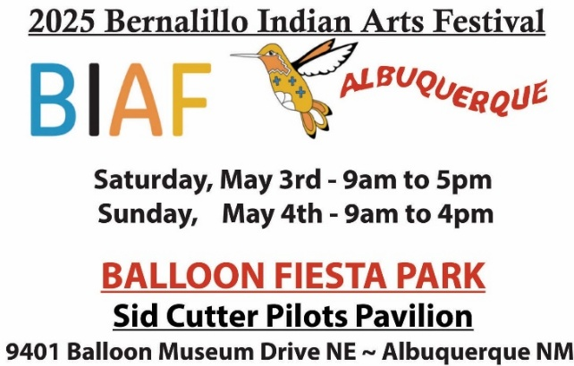

APPLICATION FEE: $35 due with application (non-refundable)

NOTE: EACH ARTIST must fill out all applications SEPARATELY and MUST pay $35 application fee. TRIBAL DOCUMENT(S): we need a copy of your CIB or letter with this application, please

**First Name Last Name**

**Address**

**City State Zip/Postal Code**

**Country Email**

**Phone (cell) (home)**

**Your Website URL:**

Eligibility for Juried Art:

***The jury process is on-going and you will be notified promptly if you are accepted or not.* Authentic Native Arts Association, Inc and the Bernalillo Indian Arts Festival comply with the Native American eligibility requirements of the Indian Arts & Crafts Act of 1990. ALL APPLICANTS must include with this application a copy of his or her tribal enrollment form or Artisan Letter from a Federal recognized tribe.**

**Juried Classification: Select one or two of the following classifications of your artwork. Mark your primary**

**classification with a “1,” secondary classification with a “2.” Note: 10% of Juried artists’ booths can also contain**

**Approved commercial items**

__________ Jewelry and lapidary work Weavings and textiles

Pottery Basketry

Painting/drawing/graphics/photography Personal Attire

Wooden Carvings Beadwork & Quillwork

**Sculpture (above 6”) Small Sculpture *(fetishes and non-Pueblo wooden carvings 6” and under)**

**Diverse arts \*\***

** Please give details of the type of Diverse Art (dolls, flutes, drums, bows and arrows, cultural items, etc.)

________________________________________________________________________________________

Will you have alternative/Non-traditional Arts and Crafts Merchandise: yes No Upon approval by ANAA committee, 10% of your market booth space can be for your commercial arts and crafts. Description and photos of your commercial merchandise must be submitted to us. You must also disclose to the public the origin of this art.

*NOTE: 3 PHOTOS OF CURRENT ARTWORK MUST ACCOMPANY THIS APPLICATION*

Pg. 2

Juried: Classification 1

**Image #1 Title**

**Medium: Size**

**Image #2 Title**

**Medium: Size**

**Image #3 Title**

**Medium: Size**

**Juried: Classification 2**

**Image #1 Title**

**Medium: Size**

**Image #2 Title**

**Medium: Size**

**Image #3 Title**

**Medium: Size**

Pg. 2

INDOOR BOOTH SPACES (note: each artist must pay for his space individually.)

CHECK ONE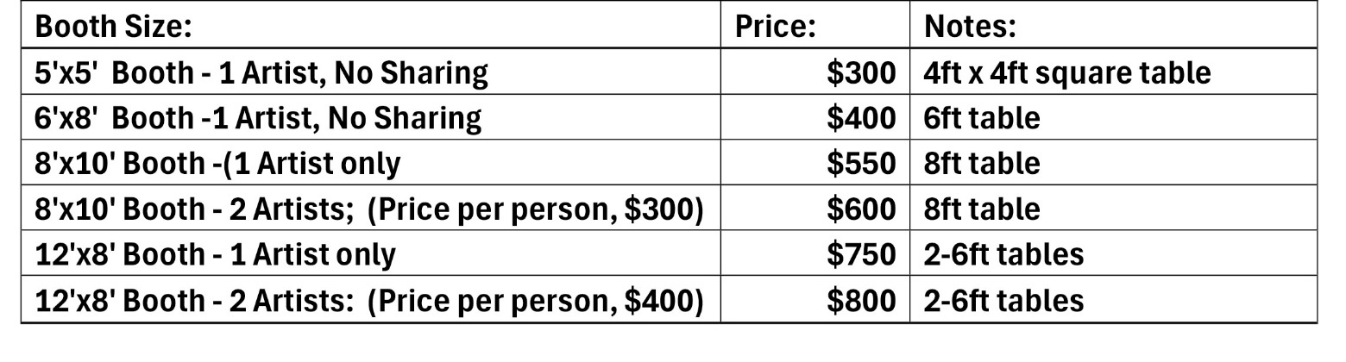

**Wall spaces – check here and also check a box above. 8x10 12x8**

**SHARINGI intend to share a booth with - Name: ____________________________________**

**NOTE: Youth artists, age 17 and younger, may sell and share a booth with a Juried Booth mentor. Youth artists do not pay an application fee or booth fee; however, before Festival day, we must have the name of the Youth Artists, their CIB and three images of their work to jury them in.**

NOTE: We provide tables and chairs. You are responsible for your own set-up and displays. We will do our best to accommodate your preference but reserve the right to make the final assignment of booth location.

Pg 3

Albuquerque New Mexico 2025 Gross receipts tax is 7.6250.

Authentic Native Arts Association, Inc is not responsible for collection the sales tax on items sold. Collection of sales tax is the responsibility of each artist. Since a list of our artist participants is available to the City of Albuquerque, and, since the city is gracious enough to support our market, we ask that you report Gross Receipts tax to: BERNALILLO COUNTY, CITY of ALBUQUERQUE , Location Code 02-100 on your New Mexico Sales tax return.

**2025 Refund Policy: if the Festival is cancelled because of wind or weather, NO refunds NO rollovers will be issued.**

**1. $35 Application Fee is non-refundable**

**2. There will be a $35 cancellation fee for all cancellations below**

**a. Until March 31, booth fee fully refundable b. April 1 to April 15, 50% refundable**

**c. April 16 to April 30, 30% refundable d. May 1 to market, no refund**

**Liability: Neither Authentic Native Arts Association, Inc. nor the City of Albuquerque Parks & Recreation Dept. is liable for any theft or damage to an artist’s merchandise or personal property. ANAA, the City of Albuquerque NM, and the Festival event’s staff, agents, representatives and volunteers will not be held responsible for any lost, stolen, or damaged property of exhibitors, their representatives, customers or any other person and/or injury to any person participating in is event for any reason. Read the statement below and sign:**

***All applications, images, and other materials submitted will become the property of the for benefit of Bernalillo Indian Arts Festival and will not be returned.***

***My signature below indicates that I have read the rules, meet the eligibility requirements of the Festival and that this application is truthful and complete to the best of my knowledge.***

**Signature: Date:**

Enclosed: Application fee - $35 (non-refundable)

* **A money order or cashier’s check made out to: ANAA**

## **I am paying with Paypal https://**[**www.paypal.me/anaagallery**](http://www.paypal.me/anaagallery)

* **Attached is a copy of my tribal affiliation paperwork**

check here if you will allow us to use your images for advertising.

PHONE INFO: We are available by phone to take credit card payments. Call our office with your credit card information 505-867-9667. We DO NOT keep any records of credit card information, so you can be sure it is all confidential.

# Mail application(s) to: Sara Chadwick, Authentic Native Arts Assoc. Inc.,

# PO 2110, Corrales NM 87048

For questions contact:

Sara Chadwick, chair 505-867-9667, or e-mail [bernalilloindianfestival@gmail.com](mailto:bernalilloindianfestival@gmail.com)